**Ideation Phase**

**Define The Problem Statement**

|  |  |
| --- | --- |
| **NM ID** | **8073B6FD2C609D2A026419D64F1FD32** |
| **PROJECT TITTLE** | **BUILD IN EVENT MANAGEMENT USING SALESFORCE** |

As you can see, ideation is not just a one-time idea generation or a brainstorming session. In fact, we can divide ideation in these three stages: generation, selection, and development.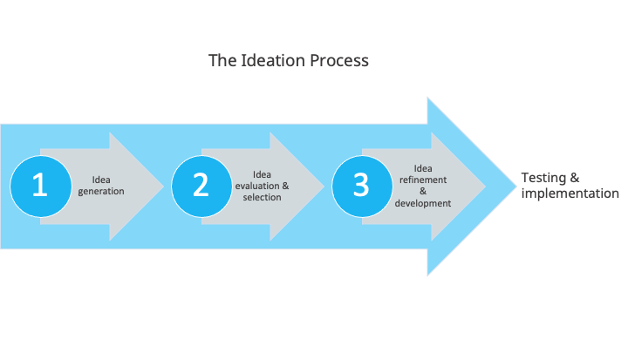

**Tools and techniques for ideation**

Ideation is meant to find solutions, ideas, opportunities, all with the goal of bringing more innovation to the organization. However, there are many obstacles that can stay in the way of innovation and badly managed ideation can be one of them.

To prevent ideation from becoming a blocker in itself, you need to remove any unnecessary barriers from the process. For example, **enable people to contribute** with ideas whenever they feel inspired.

Most of us have that Eureka moment in the least expected moments and places. Even more, if you constrain your ideation process to a workshop or session, not only are more introverted people less likely to participate, but you also risk watering down good ideas into the average of the group and end up with a lukewarm compromise.

Ideation doesn’t have to be tied to an event or a space to occur and there are many tools and techniques that can help you create a [better ideation process.](https://www.viima.com/blog/ideation-shouldnt-be-tied-to-a-time-or-a-place) Naturally, some small projects will benefit from a more focused activity like a brainstorming session, so in the end it all comes down to your goals and what you want to achieve.

For more clarity, we’ve listed below a number of tools and techniques you can use according to the ideation needs, whether they are related to idea generation, selection, or development.